17.87: To save some intermediate calculation, let the third rod be made of fractions 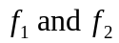 of the original rods; then 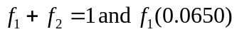 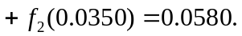These two equations in are solved for
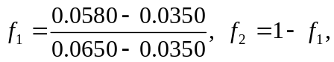
and the lengths are

